Session-6

1).Create a SQL query using GROUP BY to show the total number of orders placed by each user in an 'orders' table, displaying user_id and order_count.

Ans. SELECT
user_id,
COUNT(*) AS order_count
FROM orders
GROUP BY user_id;

Output:-
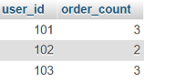

2).Write a SQL query to display the names of restaurants from a 'restaurants' table that have received an average rating above 4.0, using GROUP BY and HAVING.

Ans) SELECT
name,
AVG(rating) AS average_rating
FROM restaurants
GROUP BY name
HAVING AVG(rating) > 4.0;

Output:-

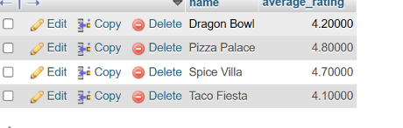
3).Suppose you have a 'payments' table with columns user_id, amount, and payment_date. Write a subquery to find user_ids who have made a single payment above ₹2000 in any transaction.

Ans. SELECT DISTINCT user_id
FROM payments
WHERE user_id IN (
SELECT user_id
FROM payments
WHERE amount > 2000
);

Output:-
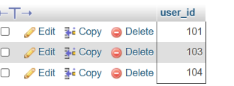

4).Using a nested subquery, display the names of movies from a 'movies' table that have a higher average rating than the overall average rating of all movies.<br><br><em><strong>Hint:</strong> Use a subquery to calculate the overall average rating, then compare each movie's average rating against it in the main query.</em>

Ans. SELECT
movie_name,
AVG(rating) AS average_rating
FROM movies
GROUP BY movie_name
HAVING AVG(rating) > (
SELECT AVG(rating)
FROM movies
);

Output:-
